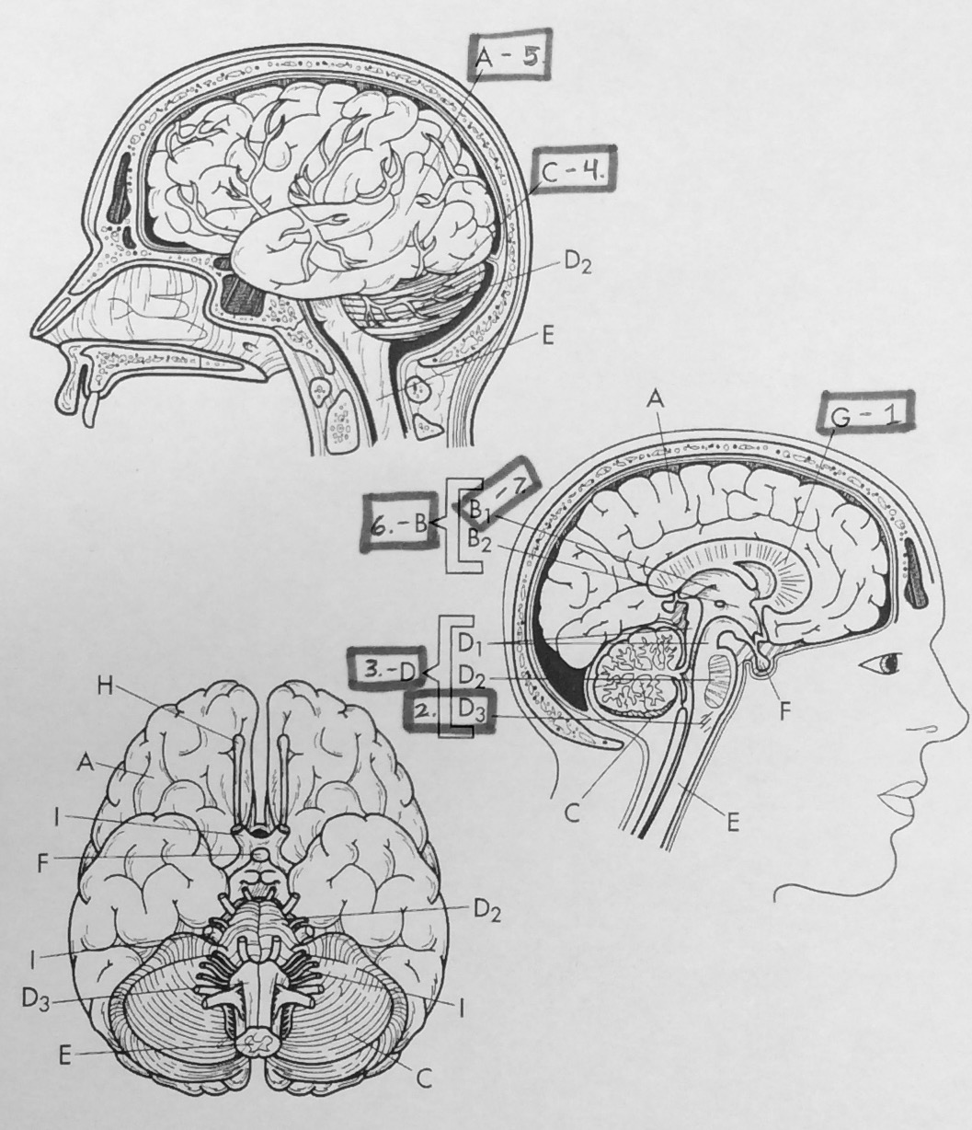

**Anatomy/Physiology**

**Mr. McKenzie**

**Nervous System Test Questions:**

Label the parts of the brain.

1. ____________________________ 5. ____________________________

2. ____________________________ 6. ____________________________

3. ____________________________ 7. ____________________________

4. ____________________________

8. The peripheral nervous system includes

1. The somatic nervous system
2. The brain
3. The spinal cord
4. Nuclei
5. All of the above

9. The part of the nervous system that controls smooth muscle, cardiac muscle, and glands is the

1. Somatic nervous system
2. Autonomic nervous system
3. Skeletal nervous system
4. Sensory division

10. The portion of a neuron that starts the action potential to move through the neuron is the

1. Axon
2. Dendrite
3. Presynaptic terminal
4. Trigger zone

11. A neuron with many short dendrites and a single long axon is a ___ neuron.

1. Multipolar
2. Unipolar
3. Bipolar
4. Sensory

12. The portion of a neuron that houses the nucleus and the different organelles is the

1. Axon
2. Body
3. Dendrite
4. Trigger zone

13. The cytoplasmic extensions that wrap many times around an axon and form the myelin sheaths are the

1. Microglia
2. Nodes of Ranvier
3. Astrocytes
4. Oligodendrocytes

14. Nonneural cells of the nervous system are known as the

1. Neurotransmitters
2. Dendritic spines
3. Glial cells
4. Medulla

15. Which one of the following statements is incorrect about the spinal cord.

1. It is the same size as an adult and at birth
2. It is a part of the central nervous system
3. It has 31 pairs of spinal nerves
4. It grows until we are an adult in size

16. The area of the spinal cord that is located in the sacral portion of the vertebral column, and resembles a horses tail is known as the

1. Cauda equine
2. Sacral enlargement
3. Cervical enlargement
4. Dura mater

17. The leading cause of spinal cord injury in the U.S. is

1. swimming accidents
2. gunshot wounds
3. falls
4. automobile and motorcycle

18. The white matter of the cerebellum that resembles a tree when viewed in a median section

1. Arbor vitae
2. Pons
3. Medulla Oblongata
4. Vermis

19. The numerous folds of the Cerebrum are known as

1. Sulci
2. Gyri
3. Nuclei
4. Fissures

20. Glial cells that are phagocytic and are very active during times of trauma or disease are the

1. Oligodendrocytes
2. Microglia
3. Astrocytes
4. Schwann cells

21. The area of the neuron that receives a stimulus from a separate neuron is known as the

1. Axon
2. Dendrite
3. Trigger zone
4. Neurotransmitters

22. The area of a neuron that carries the action potential through the cell is known as the

1. Axon
2. Dendrite
3. Trigger zone
4. Cell body

23. This type of neuron has many dendrites and a single axon. Also is the majority of the CNS and motor neurons is

1. Bipolar neurons
2. Unipolar neurons
3. Mulipolar Neurons
4. Sensory neurons

24. This type of neuron is made up of one dendrite and one axon. They are also some sensory organs such as the retina of the eye

1. Bipolar neurons
2. Unipolar neurons
3. Mulipolar Neurons
4. Sensory neurons

25. The majority of the spinal cord accidents happen to individuals

1. Between the ages of 5 to 15
2. That are female
3. Who are male
4. Between the ages of 16 to 30
5. Both c and d

26. Spinal nerves that control the chest muscles, part of the abdomen and muscles of the back are the

1. Cervical nerves
2. Lumbar nerves
3. Sacral nerves
4. Thoracic Nerves

27. A spinal cord injury that results in no motor function below the level of the injury is a

1. Complete
2. Incomplete
3. Normal
4. Superficial

28. The junction between two nerve cells is called the

1. Cell body
2. Axon
3. Dendrite
4. Synapse

29. The major relay station for sensory input that projects to the cerebral cortex is the

1. Thalamus
2. Pons
3. Cerebellum
4. Hypothalamus

30. The ________ lobe is the one you use when you recall eating that tube of toothpaste behind the couch at the age of 4 with your best friend (and the one that was used when you made that bad decision in the first place).

1. Temporal
2. Parietal
3. Frontal
4. Occipital

31. The most superficial layer of the meninges is a thick, tough membrane called the

1. Dura mater
2. Pia mater
3. Arachnoid mater
4. Epidural mater

***From this list of cranial nerves:***

1. Optic (II)
2. Oculomotor (III)
3. Trochlear (IV)
4. Trigeminal (V)
5. Abducent (VI)
6. Olfactory (I)

32. Select the nerves that are involved in moving the eyes.

1. 1,2,3
2. 2,3,5
3. 1,2,4
4. 2,4,5

33. Select the nerves that are connected to something other than the brainstem.

1. 1,6
2. 3,4,5
3. 1,2,3
4. 4,6

34. Which of the following statements is true about grey matter in the brain?

1. Grey matter has myelinated axons.
2. Grey matter is made up of cell bodies with no axons.
3. The cerebellum is composed of grey matter only.
4. The corpus callosum is composed primarily of grey matter.

35. The Limbic System is composed of _______.

1. the frontal and parietal lobe
2. the corpus callosum and the brainstem
3. the diencephalon and the brainstem
4. the diencephalon and the cerebrum

36. ___ can diffuse through the blood brain barrier, and ___ can pass through utilizing mediated transport.

1. Lipid-soluble substances, water-soluble substances
2. Water-soluble substances, lipid-soluble substances
3. Nothing, water-soluble substances
4. Nothing, lipid-soluble substances